Setup PHP Environment On Windows For F1-API Test

Requirements:

Windows2012R2

[PHP 5.3.3 or later](http://windows.php.net/download#php-5.6)

[vcredist_x64.exe](https://www.microsoft.com/en-US/download/details.aspx?id=30679)

[PEAR](http://pear.php.net/go-pear.phar)

[PECL OAuth Extension for Windows](http://windows.php.net/downloads/pecl/releases/oauth/)

[Composer](https://getcomposer.org/download/) (.exe installer or composer.phar is ok)

[PHPUnit Test Framework](https://phpunit.de/)

[Xdebug 2.2.3 or later for logs](http://xdebug.org/download.php)

Please download all the files above before start.

1. Download php5.6 and unzip to C:\php-5.6.9(can change to others), this directory will be the default PHP directory for fellow steps and the current directory in cmd is always C:\php-5.6.9
2. Install vcredist_x64.exe
3. Setup PHP Environment Variables

Open System Properties- Environment Variables-System variables-Path

Add the ;C:\php-5.6.9; to the end

Run php –v in cmd to check php is installed

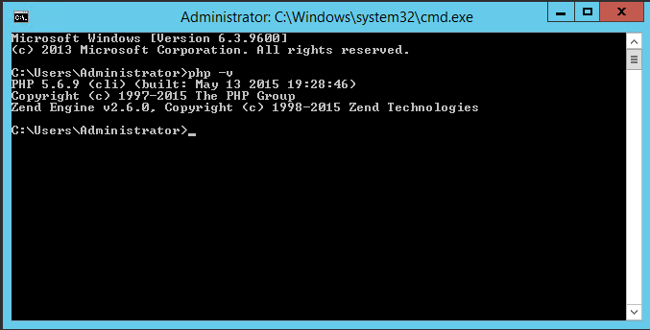

1. Rename php.ini-production to php.ini in C:\php-5.6.9\
2. Open php.ini and change ;extension_dir="ext" to extension_dir="C: \php-5.6.9\ext"
3. Remove semicolon from fellow lines:

extension=php_bz2.dll

extension=php_curl.dll

extension=php_gd2.dll

extension=php_gettext.dll

extension=php_mysql.dll

extension=php_mysqli.dll

extension=php_openssl.dll

extension=php_pdo_mysql.dll

extension=php_sockets.dll

extension=php_xmlrpc.dll

1. Install PEAR

Copy go-pear.phar to C:\php-5.6.9

Run php go-pear.phar in cmd as administrator role, follow default settings to finish.

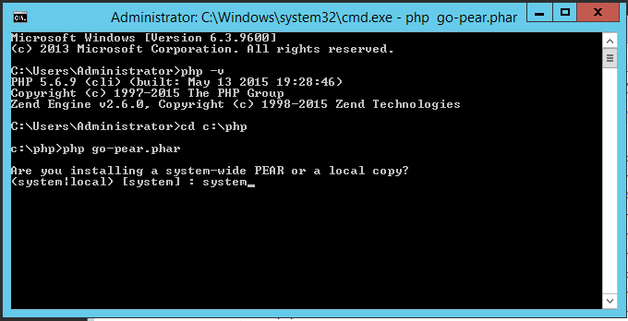

Run pear version in a new cmd to check PEAR is installed

1. Install PECL OAuth Extension

Copy php_oauth.dll to C:\php-5.6.9\ext

Add fellow line in php.ini

extension=php_oauth.dll

1. Install PHPUnit (phpunit.phar)

Copy phpunit.phar to C:\php-5.6.9

Run commands:

echo @php "%~dp0phpunit.phar" %* > phpunit.cmd

Run phpunit --version in a new cmd to check PHPUnit is installed

1. Install Composer

Run commands:

php -r "readfile('https://getcomposer.org/installer');" | php

echo @php "%~dp0composer.phar" %*>composer.bat

Run composer –V in a new cmd to check Composer is installed

1. Install Xdebug

Copy php_xdebug-2.3.2-5.6-vc11-x86_64.dll to C: \php-5.6.9\ext

Create folders C:\PHPWeb\xdebug\trace C:\PHPWeb\xdebug\profiler to store debug logs

Add fellow lines in php.ini

[Xdebug]

zend_extension="C:\php-5.6.9\ext\php_xdebug-2.3.2-5.6-vc11-x86_64.dll"

xdebug.auto_trace=1

xdebug.collect_params=1

xdebug.collect_return=1

xdebug.trace_output_dir="C:\PHPWeb\xdebug\trace"

xdebug.profiler_enable=1

xdebug.profiler_output_dir="C:\PHPWeb\xdebug\profiler"

Setup F1-API Project:

You can fellow Tracy’s Introduction on the [GIT](https://github.com/fellowshiptech/f1api-php-tests)

1. Download or using TortoiseSvn to pull F1-API Project from [GIT](https://github.com/fellowshiptech/f1api-php-tests)
2. Unzip files to C: \f1api-php-tests-master
3. Rename settings.template.php to settings.php in C: \f1api-php-tests-master\lib
4. Enter api key, secret, username and password for each environment in settings.php
5. Set the appropriate environment within the "setupBeforeClass" method in C: \f1api-php-tests-master\tests\ activities.php (Or orther .php files in this folder)
6. Open cmd window and change current path to C: \f1api-php-tests-master\ and run cmd:

Cd C: \f1api-php-tests-master

composer install

composer update

The update will take some time……………………………………

HA! Everything is done!

To test the api:

Set defaultTimezone in php.ini to be: date.timezone = UTC

Open cmd and change current path to C: \f1api-php-tests-master\tests

cd C: \f1api-php-tests-master\ tests

Run the tests based on the realm to be tested in cmd:

phpunit --debug people

phpunit --debug giving

phpunit --debug groups

phpunit --debug events